**ECS797 Machine Learning for Visual Analysis Lab 1: Image Classification using a Bag-of-Words model**

Report of Ekaterina Lyapina (Student ID: 160984099)

2.4

% initialise arrays

index_test = zeros(size(TestMat(:,1)));

index_train = zeros(size(TrainMat(:,1)));

for n = 1:size(TestMat,1)

% TestMat(n,:) - our extracted feature vectors, also known as descriptor

% c - array with codewords

d = EuclideanDistance(TestMat(n,:), C);

% index will be the nearest codeword cluster

[~, index] = min(d);

index_test(n) = index;

end

for n = 1:size(TrainMat,1)

d = EuclideanDistance(TrainMat(n,:), C);

% index will be the nearest codeword cluster

[~, index] = min(d);

index_train(n) = index;

end

Bag of Features representation and histogram of features (wordid = 37). Some image patches that are assigned to the same codeword.

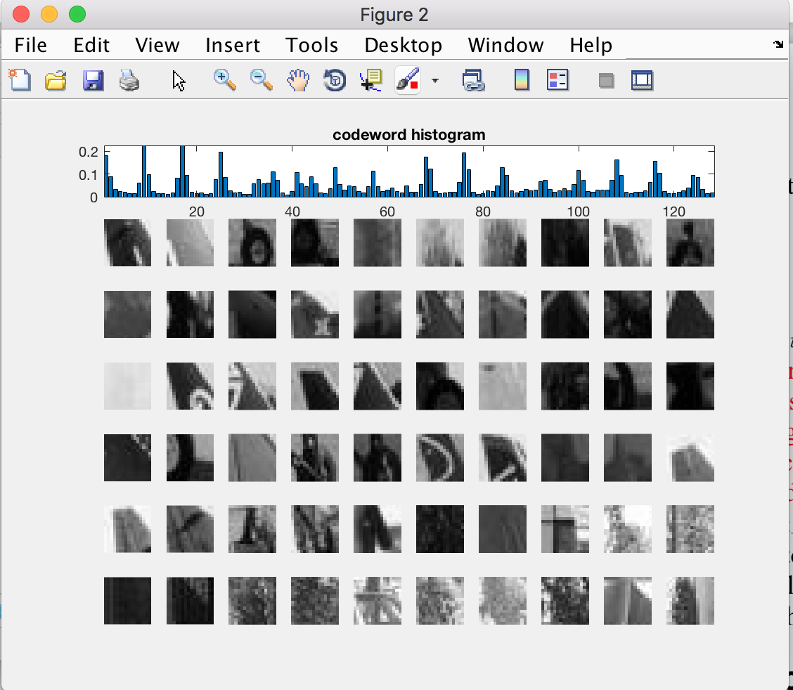

3.1

for ii = 1:nimages

image_dir=sprintf('%s/%s/','data/local', num2string(ii, 3));

% location where detector is saved

inFName = fullfile(image_dir, sprintf('%s', 'sift_features'));

load(inFName, 'features');

d = EuclideanDistance(features.data, C);

%calculate the distance

[~, index] = min(d);

%%%%histogram and normalisation with provided function

[histogram, c] = do_normalize(hist(index, vocbsize));

BoW(:,ii) = histogram;

if isshow == 1

close all; figure;

subplot(1,2,1), subimage(imread(strcat('image/', image_names{ii})));

subplot(1,2,2), bar(BoW(:,ii)), xlim([0 500]);

end

end

BoW matrix is 500x400.

4.5

function d=histogram_intersection(a,b)

p = size(a,2); % dimension of samples

m = size(b,1); % number of samples

assert(p == size(b,2)); % equal dimensions

assert(size(a,1) == 1); % a needs to be a single sample

assert(size(b,1) == 1); % b needs to be a single sample

d = zeros(m,1); % initialize output array

% d = 0;

% -------------- write your own code here ---------------

% -------------- write your own code here ---------------

sxi=sum(a);

for i=1:m

d(i,1) = 1 - (sum(min(a, b(i,:))) / sxi);

end

end

Confusion matrix (method = 1;% 1-L2; 2- Histogram intersection):

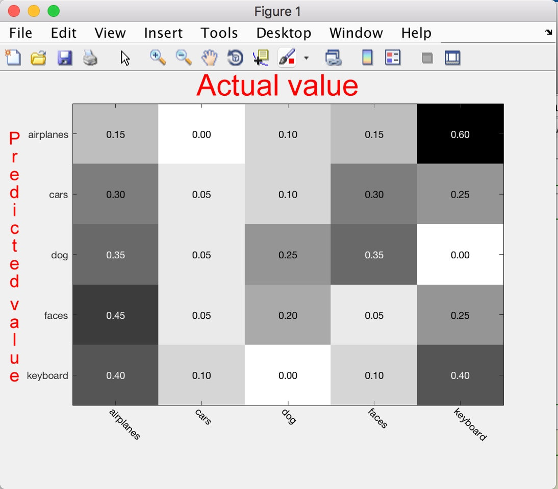

In this confusion matrix, airplanes mainly recognised as faces, only %15 is true recognition rate. Cars are poor associated with any class. Dogs class has 25% actual recognition rate, but often confused to be face class (20%). We can see from the matrix that the classification model has trouble distinguishing between face class (35%) and cars (30%) but can make the distinction between cars and airplanes (0%) pretty well. Keyboard class is mainly (60%) confused with airplanes, despite All correct predictions are located in the main diagonal of the table, so it is easy to visually inspect the table for prediction errors, as they will be represented by values outside the diagonal.

Some correct and incorrect cases (method = 1;% 1-L2; 2- Histogram intersection):

